**MULTIPLE FILE COPYING**

**LAB # 07**



**Fall 2022**

**CSE302L System Programming Lab**

Submitted by: Maaz Habib

Registration No.: **20PWCSE1952**

Class Section: **C**

“On my honor, as student of University of Engineering and Technology, I have neither given nor received unauthorized assistance on this academic work.” Student Signature: ______________

Submitted to:

**Engr. Abdullah Hamid**

Saturday, December 11th , 2022

**Department of Computer Systems Engineering**

**University of Engineering and Technology, Peshawar**

**Lab Objective(s):**

* Understand and implement the select function.

**Task # 01:** Write a program that copies two files sequentially in a single process.

**Code:**

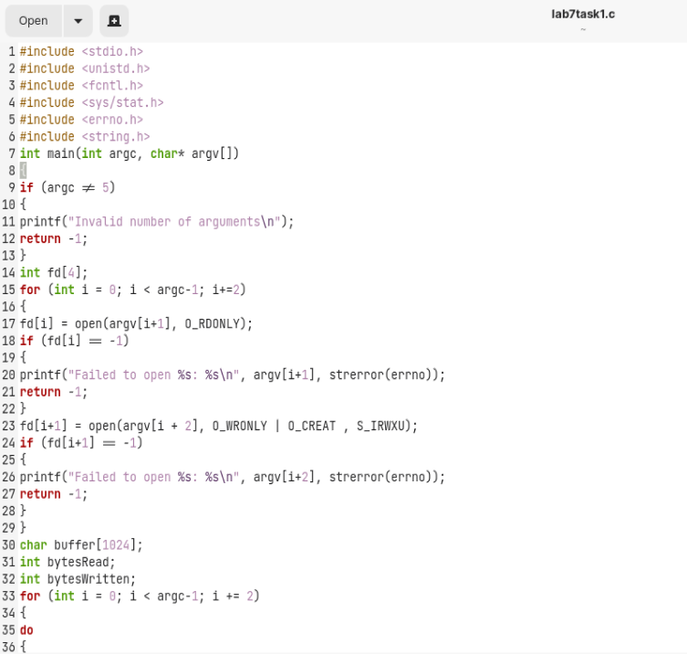

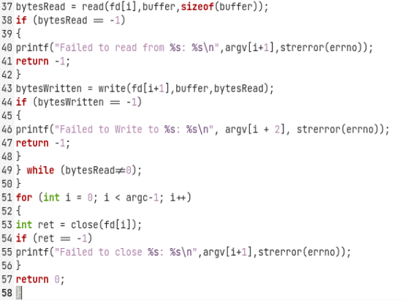

**Output:**

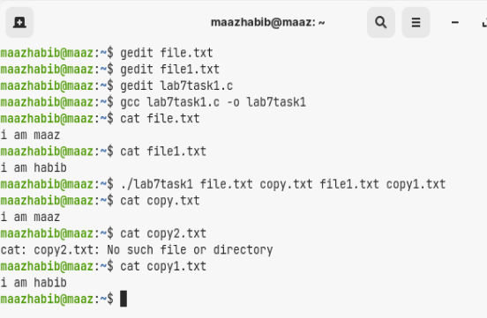

**Task # 02:** Write a program that monitors two files by forking a child.

**Code:**

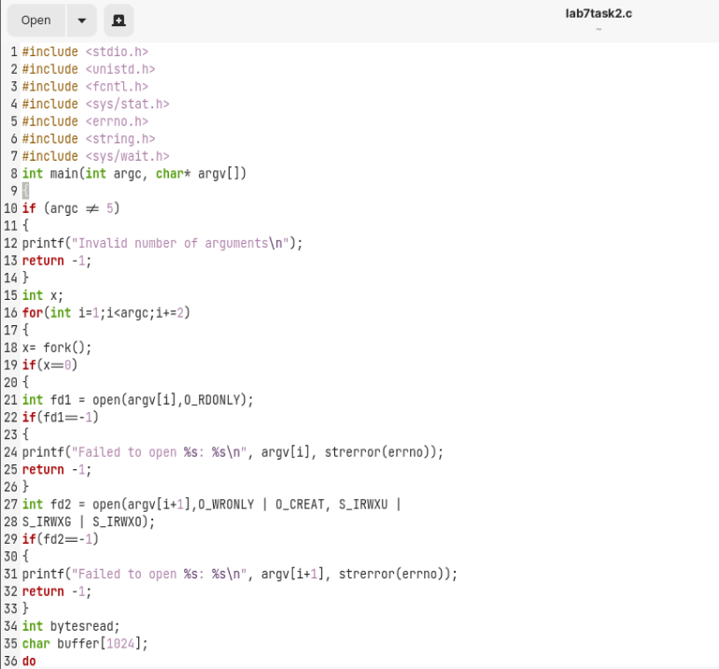

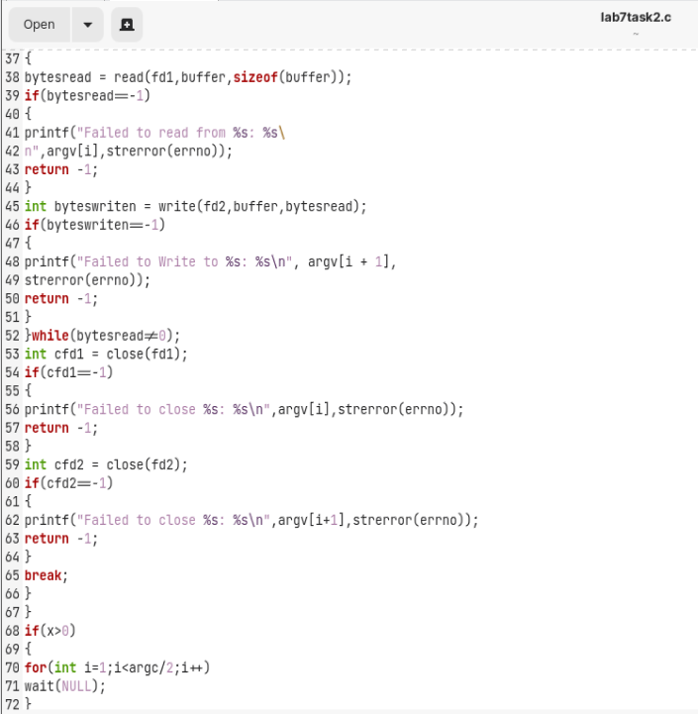



**Output:**

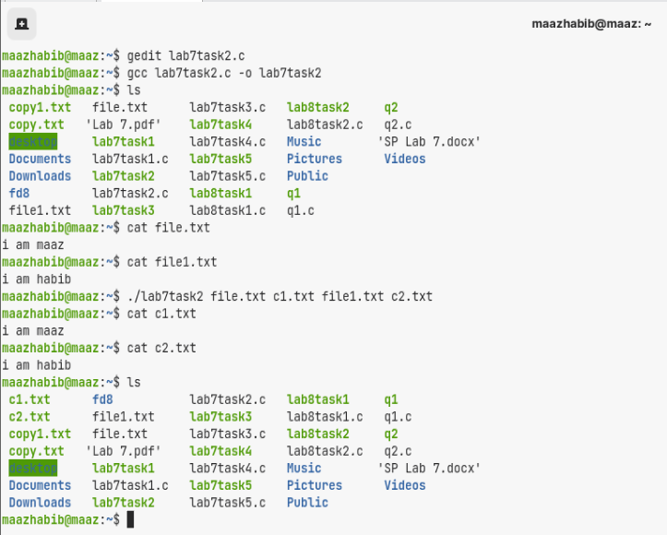

**Task # 03:** Write a program that monitors two files using 'select'.

**Code:**

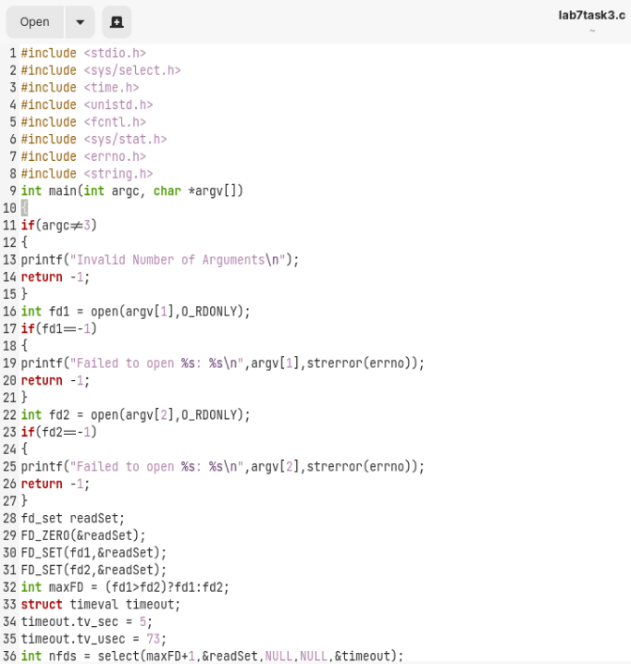

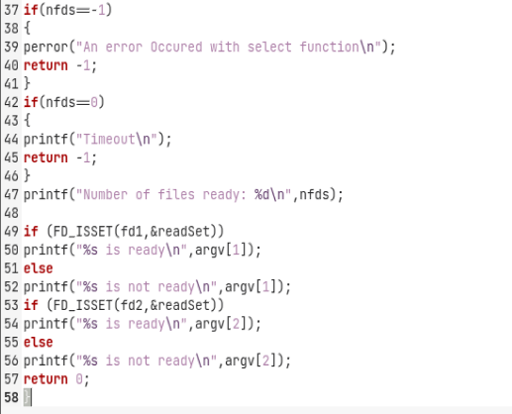

**Output:**

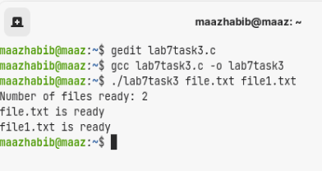

**Task # 04:** Write a program that monitors N files using 'select'.

**Code:**

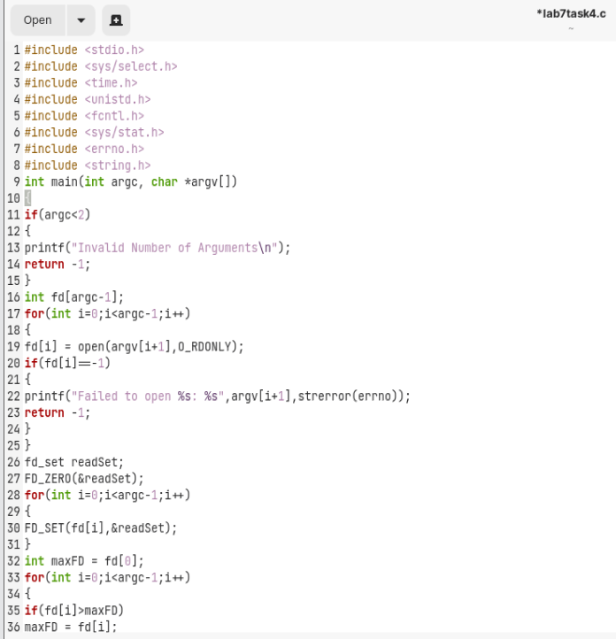

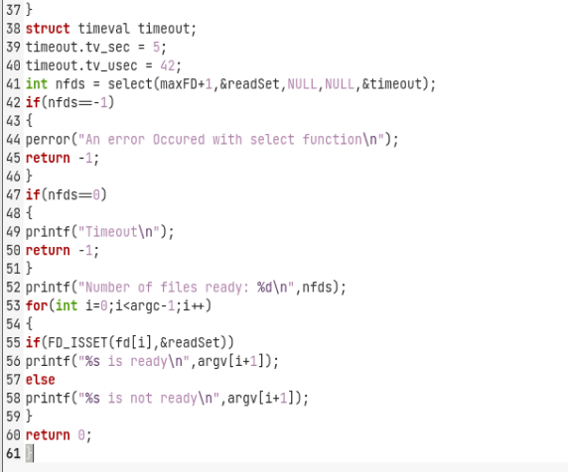

**Output:**

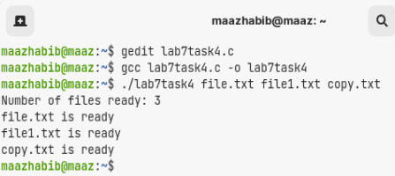

**Task # 05:** Write a function that creates a delay of N seconds using select function. Pass N as an argument to the function.

**Code:**

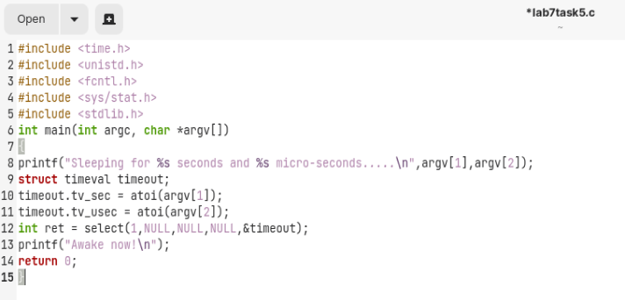

**Output:**

